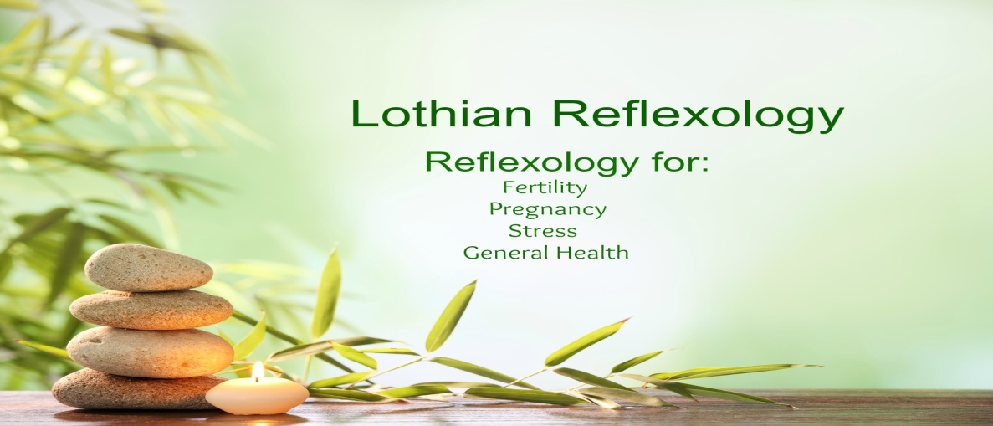
Doris Wylie
2 West Mill Court
Lasswade
Midlothian
EH18 1LH

07724 197627
doriswylie@btinternet.com
www.lothianreflexology.co.uk
Feel Good Fridays

Why you might want to participate:
- It might be nice to boost morale and finish the week on a high
- You might want to do some teambuilding with a difference
- It’s lovely and relaxing and that’s important, because:
- The more often we feel relaxed, the better we become at recognising stress before it gets a grip
- It’s fun
- It’s not expensive – taster sessions are priced below the per rata treatment rate
- It’s easy to organise
- It’ll get people interested and talking about something other than work
- It’s a quick, easy way for staff to decompress before the weekend
- You’ll get a “feel good” factor that will last beyond that Friday afternoon

What’s available:
TASTER SESSIONS:
- Reflexology or Indian Head Massage
- £10 for a 20 minute session
Reflexology uses finger pressure on the feet to relax and re-balance the whole person in mind, body and emotion. It is based on the principle that various parts of the feet relate to corresponding parts of the body and that by working on the feet the Reflexologist can create a balancing effect. The finger pressure on the feet is firm, so it should not feel tickly. Anyone can benefit from Reflexology, but it is particularly beneficial for anyone who is experiencing ill-health or who are suffering from stress or stress related illnesses. Generally clients feel deeply relaxed after a treatment and often report having had a good night's sleep and a boost in their energy levels. Really the only way to know is to give the treatment a try.
Indian Head Massage uses deep thumb and finger pressure, friction and soothing effleurage as well as laying of hands. It relaxes the scalp and helps promote feelings of well-being, leaving you feeling calm and relaxed. Indian Head Massage is done sitting in a chair, fully clothed and uses no oils or lotions and it may cause you to be more relaxed than you've ever been, sitting down.......

WORKSHOPS:
Maximum of 12 people
Length 1-1½ hours
Price - £60
Subjects: Indian Head Massage SEE BELOW FOR MORE INFORMATION
Facial Reflexology
Foot Massage
Stamp Out Stress

How it’s organised:
- You set a time and date
- You decide what you want – taster sessions or workshops
- Taster Sessions – I provide a booking sheet and staff members book slots and choose what treatment
- Payment made to me on the day by staff member or I’ll invoice the organisation
- I provide all the equipment
- You advertise what’s on offer and get staff members to sign up
- I’ll provide material explaining what’s on offer
- You provide an appropriate space – I’ll give you details of what’s required

What if:
- Fridays don’t work for your organisation:
That’s no problem, with enough notice any time on any day can be arranged
- It’s so successful you want to do it on a regular basis:
No problem, it’s the kind of treat that works well on a monthly basis, but it will mean booking well in advance
INDIAN HEAD MASSAGE  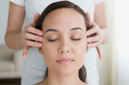  The feeling of deep relaxation brought about by head massage, can help you to recognise the early signs of stress.  If you have tight neck and shoulders from working at a desk all day, this is a wonderful treatment to relax the muscles.  Indian Head Massage uses deep thumb and finger pressure, friction and soothing effleurage as well as laying on of hands. It relaxes the scalp and helps promote physical and psychological well-being, leaving you with a feeling of tranquillity.  This is a gentle treatment that uses no oils or lotions. It is done seated down and over clothing, though it may be necessary to loosen ties or take off jewellery or hair ornaments | 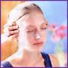  FACIAL REFLEXOLOGY  Facial Reflexology is easy to learn and very relaxing and it a great do-it-yourself treatment. There are 15 points on the face that represent areas and systems within the body. Working on these 15 points on the face may:  - Relieve headaches  - Improve concentration  - Enhance mood  - Increase relaxation and relieve stress  - Improve complexion  Working on the face increases the blood supply and improves lymphatic flow, offering a general improvement in complexion. And the technique only uses finger pressure and not oils or lotions, so there’s no need to remove make-up.
FOOT MASSAGE  - Discover how powerful working on the feet can be  - Understand when and when not to massage the feet  - Find out how working on the feet can affect the body  Foot massage is suitable for people of all ages and states of health. Anyone can benefit from foot massage, but it’s particularly good:  - during pregnancy  - to relax children before bedtime  - for anyone who is tense or stressed  - for older people  - as a relaxing treat  Foot massage is fuss free – you only need to remove socks and shoes – and that makes it easy to do with family members when watching TV or having a chat. Therapeutic touch has a healing, soothing, connecting effect that no amount of talk can achieve. | 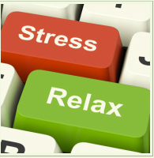  STAMP OUT STRESS  If we're stressed, we often to work harder, longer, faster - which creates even more stress, and often still doesn't get the job done. Or perhaps we just ignore the problem and hope it goes away.  Stress can make it difficult to relax: our mind tends to race and our body seems to accumulate tension. Stress is known to be responsible for many physical and psychological issues.  When you're feeling stressed, the best thing you can do is .... STOP. Because, relaxation is the antidote to stress and the better you are at relaxing the better you will be at managing stress.  Dealing with stress may take time, energy and a resolve that you just don't have at the moment. You may need to build up your resources, and accepting a helping hand can make that easier and quicker.
If you want to book a Feel Good Friday session or if you wish any further information please call Doris Wylie on 07724 197627 or email doriswylie@btinternet.com.

