Supercharge
Your Results
in 2018

The Workbook That Shows You
How to Turn Your Resolutions into Results in 2018
Release 2017
All too often we rush forward with what we want to achieve without taking stock of where we’ve been, learning the lessons and letting go of what has been. And if we don’t - to use the Hollywood parlance - “consciously uncouple” from the past, it’s all too easy to carry all that “stuff” from the past into the present and that can drain our energy and drag us down. And the last thing we need when we’re reaching forward to new challenges and goals is a drag on our energy!

Write your reflections on 2017

What were the best bits?

What would you not like to repeat?

What did you learn about yourself?

I’m proud of myself because ...

What are now now ready to let go of?

What do you need to express in order to be ready
to let go of 2017 now?
2017 Letting Go Ceremony
Take a moment to read your responses to the 2017 questions. Make any amendments you feel helpful or necessary.

Now, close your eyes and take a long slow breath in, and as you breathe out, feel all the tension ooze out of your body. Do that another couple of times. Continue to breathe slowly and calmly and turn your attention to the year you’ve just completed. Begin in January 2017 and look back through your year in your mind’s eye as if you’re watching it on a movie screen. Notice all the significant events.

Because you’re watching the screen you’ll not feel any of the negative emotions you may have experienced, but feel free to give yourself permission to jump into the screen to re-live the highlights. You might even want to take those positive emotions back with you then you return to your seat!

Take your own time to work through your year, month by month. Allow your unconscious mind to learn the lessons. Consciously take all the positive emotions because they help you generate energy and positivity. It’s OK to leave behind the negative emotions because they’re a drag on your energy.

As you get to the end of 2017 allow the screen to turn white and notice how all the images disappear from the screen.

You’ve just taken the best bits of 2017 with you into 2018 and left the not so good bits behind, where they belong.

Give yourself a clap on the back.

Really .... actually .... physically give yourself a clap on the back, now. You’ve done a great job and helped to ensure your success in 2018.
Your 2018 Goals
There’s a very specific sequence that helps you manifest your goals and that sequence begins with a thought: if you haven’t thought it, you can’t create it. Most of us tend to aim for what we think we can achieve, rather than having big dreams aiming for what we actually want. And that’s OK. It can feel very uncomfortable to aim for those big dreams, but perhaps when you’re thinking of what you want for 2018, you can stretch your ambitions just a little and ask for a bit more – after all, if you don’t ask, you won’t get!

After the thought, comes the word. Thinking is more powerful if you write your thoughts down. There’s something about the act of picking up a pencil or pen and writing it down that not only gets the thoughts out of your head, but somehow, magically, the physical act of picking up the pen and actually writing the words seems to turn the thoughts into something more concrete, something more tangible, something which inhabits the physical world. So it’s important to write down your goals.

Then comes the action. Goals, whether they are thoughts or have been written down need energy to manifest and that takes action. You want to be clear about what you need to DO in order to make your goals into reality.

Now, are you ready to create a fabulous 2018?
- Yes

How fabulous do you want it to be?
- Better than my wildest dreams
- Totally absolutely fabulous
- Wonderful beyond my ability to imagine
- Exceptional, exciting, and excellent

Is anything preventing you from achieving this? If so, what?
_____________________________________________________________________________________________________________________________________________________________________________________________________________________________________________________
Have A “Whole” Life Plan
All too often when we set goals and ambitions, we only focus on parts of our life – relationship, career, finances, etc. Doing this certainly helps you focus, but it can leave your life lop-sided – you become successful in certain areas of your life, while other areas of your life feel unfulfilled. You will get much better results and feel much more satisfied with life, if you have a plan that will improve all areas of your life.

Complete this Wheel of Life by scoring each area of your life with a mark from 1-10 (1 = awful and 10 = fabulous). And you can change the headings to give you an overview of your life at present.

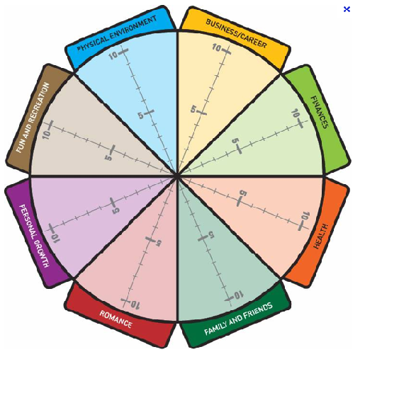

To Improve All Areas Of My Life, my goals for 2018 are:

Engage Emotionally With Your Goals

You’ve perhaps heard of SMART targets –Specific, Measurable, Achieveable, Realistic and Timebound. That’s the gold standard of target setting, but SMART targets can often be a bit uninspiring when you feel you “need to” or “should” do something. You’ll get a lot further and be a lot more successful if you pick goals that you really want to achieve, goals that motivate you and make your heart sing, goals that get you all fired up. Motivation is an emotion that will drive you to achieve your goals, so make sure you’re emotionally attached to them.

How Much Do I Really Want To Achieve My Goals?

Avoid Having Money As A Goal

Money’s important, but for most people, money isn’t the reason WHY they do what they do. It’s what money gets them that drives them to achieve financial goals: freedom, peace of mind, recognition, security, etc. Most of us work to live, rather than living to work – and if you ask me, that’s exactly right. Too large a focus on money can lead you to live to work, rather than working to live. Trust that if you do what you love the money will follow.

What Do My Financial Goals Give Me?

Some extra thoughts for 2018 ...

In 2018 I give myself permission to ......

2018 will be the year that .....

In 2018, I give myself the gift of .....

In 2018, I allow myself to release .....

The word which describes 2018 for me is .....

Contd ...

How I’d like to feel in 2018

What I’d like to learn in 2018

Five things I want to celebrate about myself in 2018
1.
2.
3.
4.
5.

Five things I want to stop doing in 2018
1.
2.
3.
4.
5.

Decide, Commit, Review

Wanting something isn’t the same as DECIDING you’ll achieve it. Once you decide that something will be so, you unconsciously begin to target in on that objective. Without a decision your goal is only a wish or a hope.

And it’s only when you make a clear decision that you can really COMMIT to achieving the outcome. Once you make a real commitment to your goal, you will feel able to take whatever actions are required to achieve your objective. Commitment helps you overcome your inner fears and objections to doing what needs to be done to achieve your objective.

But commitment requires regular REVIEW to allow you to adjust your plan to ensure you achieve your outcome. A year is too long a time to have a goal without reviewing progress. Your goals may require to be broken down into smaller chunks, or if your strategy isn’t working you may require to change your approach in order to reach your goal. A quarterly review is the minimum requirement and it would be preferable to review your goals monthly to ensure you keep on track.

So, here’s how to keep your goals for 2018 on track:

Decide, Commit and Review your 2018 goals. Choose one goal from each section of your wheel of life – they may not all take a year to achieve and that’s OK. List them (and check that they’re SMART – specific, measurable, achieveable, realistic and timebound ie you schedule when you’ll do it).

My Goal for Business/Career is:

Goal
_____________________________________________

_____________________________________________

- I’ve decided I’ll achieve this goal

I know I’m committed to this goal because:

_____________________________________________

I will next review my progress towards this goal by:

______________________________________________

My Goal for Finances is:

Goal
_____________________________________________

_____________________________________________

- I’ve decided I’ll achieve this goal

I know I’m committed to this goal because:

_____________________________________________

I will next review my progress towards this goal by: ______________________________________________

My Goal for Health is:

Goal
_____________________________________________

_____________________________________________

- I’ve decided I’ll achieve this goal

I know I’m committed to this goal because:

_____________________________________________

I will next review my progress towards this goal by: ______________________________________________

My Goal for Family & Friends is:

Goal
_____________________________________________

_____________________________________________

- I’ve decided I’ll achieve this goal

I know I’m committed to this goal because:

_____________________________________________

I will next review my progress towards this goal by: ______________________________________________
My Goal for Romance is:

Goal
_____________________________________________

_____________________________________________

- I’ve decided I’ll achieve this goal

I know I’m committed to this goal because:

_____________________________________________

I will next review my progress towards this goal by: ______________________________________________

My Goal for Personal Growth is:

Goal
_____________________________________________

_____________________________________________

- I’ve decided I’ll achieve this goal

I know I’m committed to this goal because:

_____________________________________________

I will next review my progress towards this goal by: ______________________________________________
My Goal for Fun and Recreation is:

Goal
_____________________________________________

_____________________________________________

- I’ve decided I’ll achieve this goal

I know I’m committed to this goal because:

_____________________________________________

I will next review my progress towards this goal by: ______________________________________________

My Goal for Physical Environment is:

Goal
_____________________________________________

_____________________________________________

- I’ve decided I’ll achieve this goal

I know I’m committed to this goal because:

_____________________________________________

I will next review my progress towards this goal by: ______________________________________________

Annual Plan

Schedule in what will happen when:

January | February | March
April | May | June
July | August | September
October | November | December

Monthly Plan

1
2
3
4
5
6
7
8
9
10
11
12
13
14
15
16
17
18
19
20
21
22
23
24
25
26
27
28
29
30
31

DAILY ACTIVITY SHEET

DATE: ......................................................................

Scheduled Events Preparations
Time | Event | What to take with me, remember, etc

Today’s MOST IMPORTANT TASKS

- ....................................................................................................................................
- ....................................................................................................................................
- ....................................................................................................................................

After my 3 Most Important Tasks (if there’s time) | Phone calls/emails

Notes:

....................................................................................................................................................

....................................................................................................................................................

....................................................................................................................................................

