Discover the 5 stages of stress

Stress levels change according to how we respond to external factors. One day we may wake up feeling full of vitality and ready to tackle anything - no matter what comes our way we will cope well. Another day we wake up feeling low in energy and not very positive - whatever comes our way that day will be an effort, and even the simplest things may cause us stress.

These fluctuations are quite normal and won’t cause any serious harm. In terms of your ability to copy and general sense of well-being it will be helpful if you can find ways to manage the low energy days - some relaxation and movement exercises could be very useful tools.

Stress becomes a problem when the stimulation is at too high a level for too long. This will lead to distress - we will perceive the demands on us as being more than our ability to cope. This situation does need to be managed - for the sake of our health.

Let’s look at how the stress curve works

There are five stages in the stress curve:

Everyone when they are in each stage will demonstrate the same characteristics and actions, although not everyone will be in the same stage when responding to the same stimuli: the extrovert may find giving a presentation takes them to stage 2, whereas the introvert may find giving the same presentation takes them to stage 4.

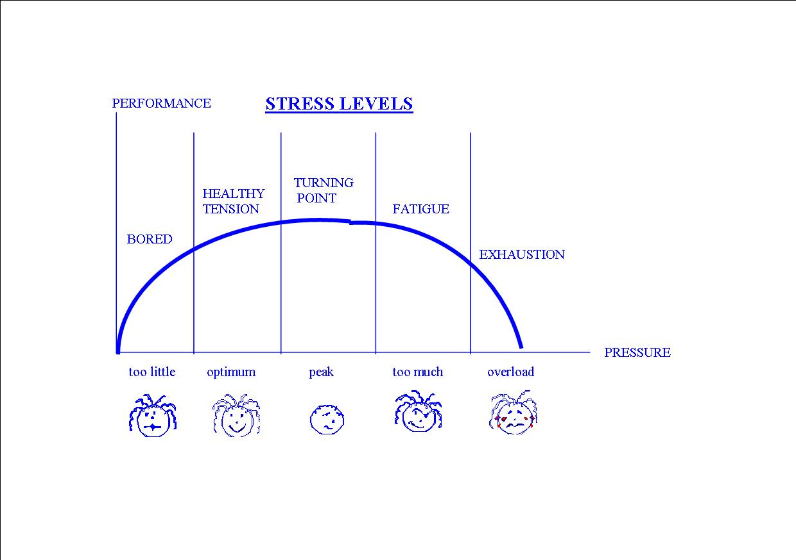

STAGE 1 - BOREDOM
Characteristics - under challenged, no motivation, can’t get moving, depressed, not looking forward to life, frustration.

Antidote - increase exercise levels, increase social contact, increase stimulation/interest.

STAGE 2 - OPTIMUM
Characteristics - positive, stimulated, alert, motivated, decisive, creative, sociable, sleeps well, sense of well-being.

Maintenance - balance between time spent on work/rest/ play, and balance in lifestyle between exercise/ diet/relaxation, be assertive - say NO to too much.

STAGE 3 - PEAK
Characteristics - intense activity but higher anxiety, attention to detail, razor sharp focus, poor communication, insensitive to others, poor delegation, loss of balance - too much work/not enough play or sleep.

Antidote - adjust time and lifestyle to return to balance, take some of the pressure off yourself.

STAGE 4 - DISTRESS
Characteristics - managing with pressure but fired up for too long; communication gets worse; withdrawn; easily upset; loss of sense of humour; reduced efficiency; irritability; mood swings; indecisive; anxiety; poor sleep patterns; accident prone; confused; memory lapses.

Antidote - admit problem; ask for help; delegate; increase relaxation, time and lifestyle management; prioritise.

STAGE 5 - EXHAUSTION
Characteristics - sleep disturbed, gets ill, tired, not coping, angry, dreading the day ahead, not managing pressure. It can be difficult to get back from this point.

Antidote - seek medical help, reduce demands on yourself (or your body will do it for you by embracing illness), increase relaxation time, increase levels of support at work at home, socially and medically.

The law of diminishing returns applies to the stress curve. After stage 3, the more effort you put into getting things done, the less you will actually achieve. Finding the optimum range for us in the stress curve is vital for us all if we wish to manage stress effectively.

Maintaining the correct level for you on the stress curve depends on:
1. being aware of your stress levels
2. knowing about the stress curve
3. assessment of your position on the stress curve
4. anticipating future events
5. taking action accordingly
6. rebalancing

There are two ways to reduce stress and manage pressure:

- Change how you feel
- Change how you think

Self awareness is the key, because if you manage pressure you can avoid stress because:

You can’t be stressed and relaxed at the same time.

